**NUCLEO DE TRANSFORMADORES COMERCIALES.**

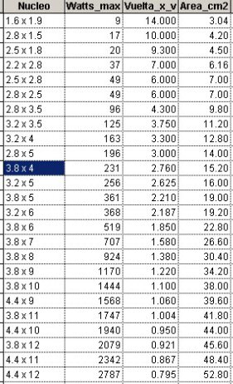

**AMPERAJE DEL CABLE AWG SEGUN EL GROSOR.**

|  |  |
| --- | --- |
| **# DEL CABLE** | **AMPERAJE ( I )** |
| **6** | **53.16** |
| **7** | **44.2** |
| **8** | **33.3** |
| **9** | **26.5** |
| **10** | **21.2** |
| **11** | **16.6** |
| **12** | **13.5** |
| **13** | **10.5** |
| **14** | **8.3** |
| **15** | **6.6** |
| **16** | **5.2** |
| **17** | **4.1** |
| **18** | **3.2** |
| **19** | **2.6** |
| **20** | **2.0** |
| **21** | **1.6** |
| **22** | **1.2** |
| **23** | **1.0** |
| **24** | **0.8** |
| **25** | **0.6** |
| **26** | **0.5** |
| **27** | **0.4** |
| **28** | **0.3** |
| **29** | **0.26** |
| **30** | **0.20** |
| **31** | **0.18** |
| **32** | **0.12** |
| **33** | **0.10** |
| **34** | **0.08** |
| **35** | **0.06** |

**PESO DEL CABLE AWG SEGÚN EL GROSOR.**

|  |  |
| --- | --- |
| **# DEL CABLE** | **PESO DEL CONDUCTOR Kg/Km** |
| **22** | **2.96** |
| **23** | **2.36** |
| **24** | **1.87** |
| **25** | **1.48** |
| **26** | **1.18** |
| **27** | **0.939** |
| **28** | **0.747** |
| **29** | **0.592** |
| **30** | **0.472** |
| **31** | **0.376** |
| **32** | **0.300** |
| **33** | **0.236** |
| **34** | **0.188** |
| **35** | **0.151** |
| **36** | **0.119** |
| **37** | **0.095** |
| **38** | **0.076** |
| **39** | **0.060** |
| **40** | **0.048** |
| **41** | **0.037** |
| **42** |  |

|  |  |
| --- | --- |
| **# DEL CABLE** | **PESO DEL CONDUCTOR Kg/Km** |
| **1** | **377.0** |
| **2** | **299.0** |
| **3** | **237.0** |
| **4** | **188.0** |
| **5** | **149.0** |
| **6** | **118.0** |
| **7** | **93.7** |
| **8** | **74.4** |
| **9** | **58.9** |
| **10** | **46.8** |
| **11** | **37.5** |
| **12** | **29.9** |
| **13** | **23.6** |
| **14** | **18.7** |
| **15** | **14.9** |
| **16** | **11.8** |
| **17** |  |
| **18** |  |
| **19** |  |
| **20** |  |
| **21** | **3.75** |